Learn to use the Linux Terminal
Lesson Plan for learning how to create content with Audacity
Don Watkins

OVERVIEW & PURPOSE
The student will learn how to open a terminal session and to input simple commands that can be used on most Linux systems.

EDUCATION STANDARDS
ISTE Learning Standard 1D: Students understand the fundamental concepts of technology operations, demonstrate the ability to choose, use and troubleshoot current technologies and are able to transfer their knowledge to explore emerging technologies.

OBJECTIVES
- Student will learn to use the Linux terminal to complete simple commands and tasks.

MATERIALS NEEDED
- Linux Laptop
- Linux terminal

Instructions
- Turn on the computer.
- Login with userid and password.
- Press Control + t to open a terminal on Ubuntu. On Fedora you must go to Gnome Menu to open the terminal.
- In the terminal window enter ‘$ ls’
- What did you observe?
- Now enter ‘ls -l’ at the prompt. How did the output change?
- Let’s create a few files. We can to that easily with the ‘touch’ command.
  - $ touch one
  - $ touch two
  - $ touch three
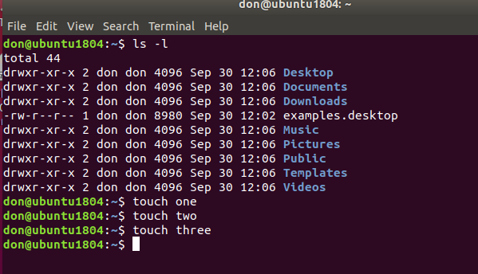
8. Enter ‘ls -l’ at the prompt now. What do you see?
9. Let’s remove one of those files. Enter ‘rm one’ then enter ‘ls -l’. What do you see?
10. Let’s use the ‘clear’ command to clear up the terminal.
11. Enter ‘top’ at the command prompt. What do you see?
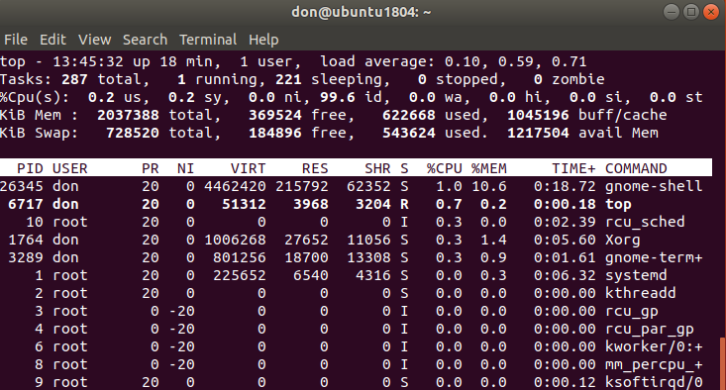
12. The ‘top’ command displays all the currently running processes on this Linux computer.
13. We will use the ‘cal’ command to display calendar dates. We can use this command to find what days of the week that important events occurred. That could be the 4th of July 1776. Enter the command ‘cal 7 1776’. The ‘7’ indicates the month of July. 1776 is the year. Here is the result.
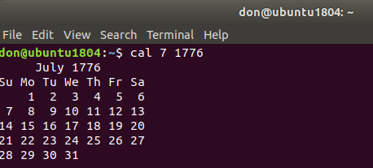
14. Now try some other important dates. What about your own birthday? What about the other members of your family.
15. It’s easy to find help for these commands on Linux by using the ‘man’ pages. At the command prompt enter ‘man cal’. See the result below.
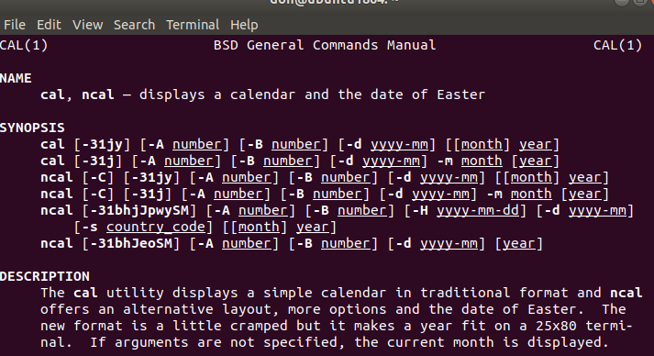
16. Use the ‘man’ command to find out more about ‘top’ and ‘touch’.

Further Study
Further study :
Master the Linux ls Command
Use the Calendar and Date Functions in Linux

This work is licensed under a Creative Commons Attribution 4.0 International License.

